Bathroom Equipment

Item Name | Function |  | Price Range*
Elevated toilet seat | Raise height of toilet seat. Highly recommended for after a hip replacement. | 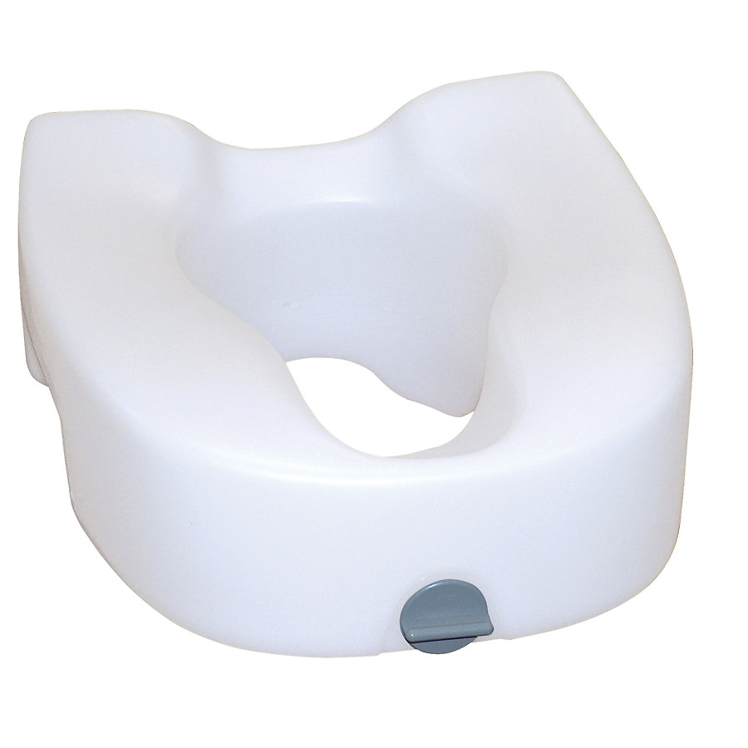 | Provided by hospital, if medically necessary
3-in-1 Commode | 3 Functions:  1. Shower chair  2. Stand-alone toilet  3. Raise height of existing toilet | 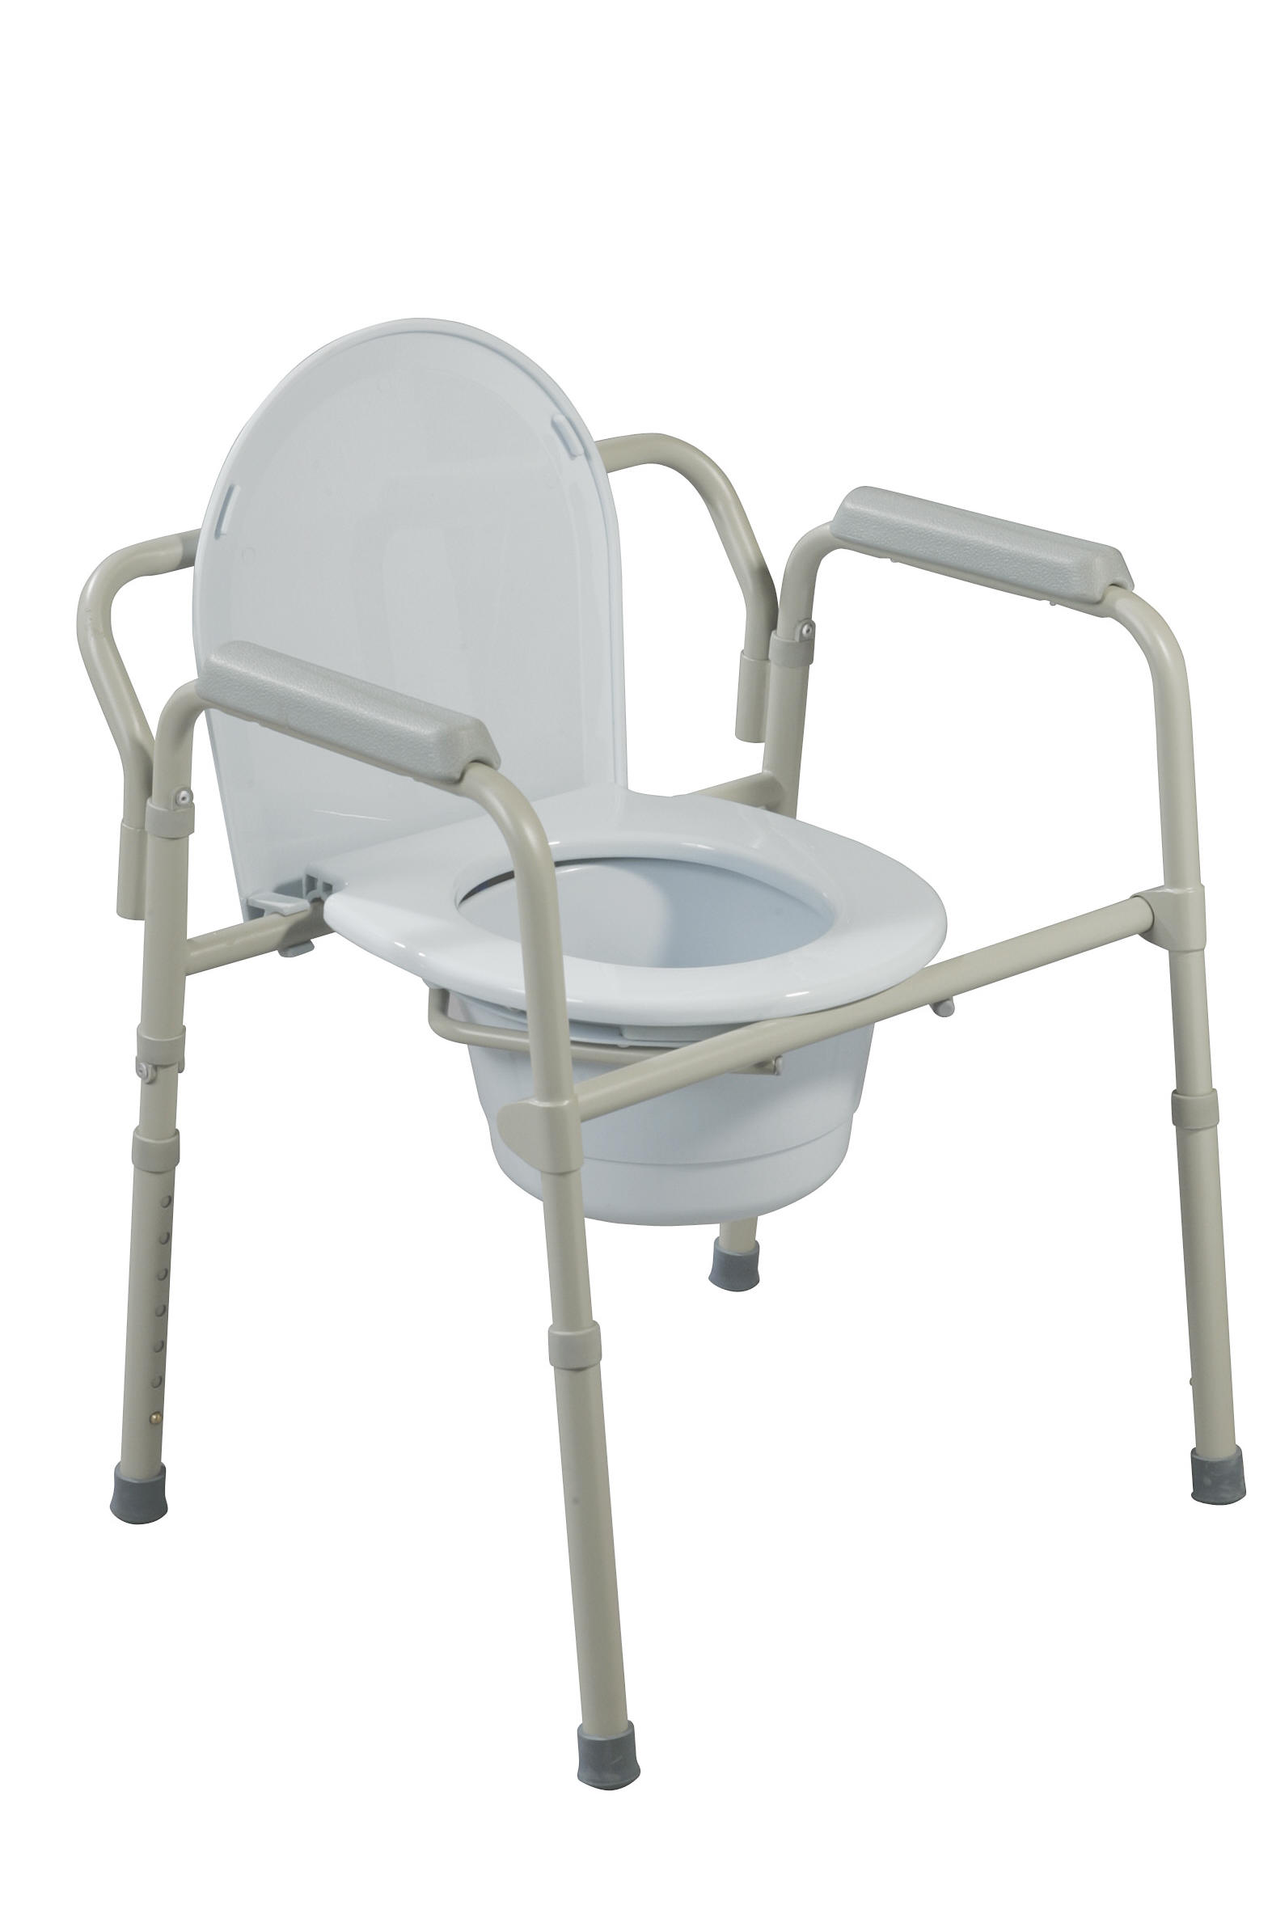 | $35-$180
Tub Transfer Bench | To assist with getting into/out of a tub shower. Removes need to step over tub ledge  *Recommend use with a handheld showerhead | 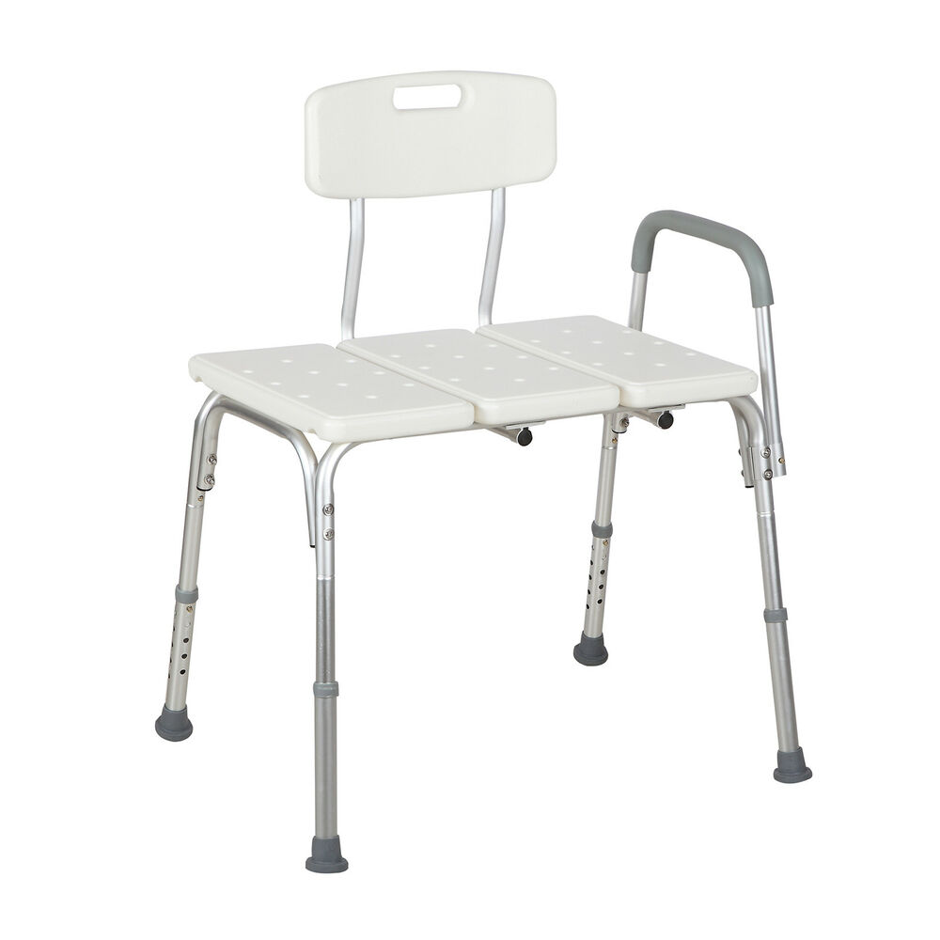 | $33-$80
Shower Chair | For use in a walk-in shower. Sit on a shower chair to save energy while bathing.  *Recommend use with a handheld showerhead | 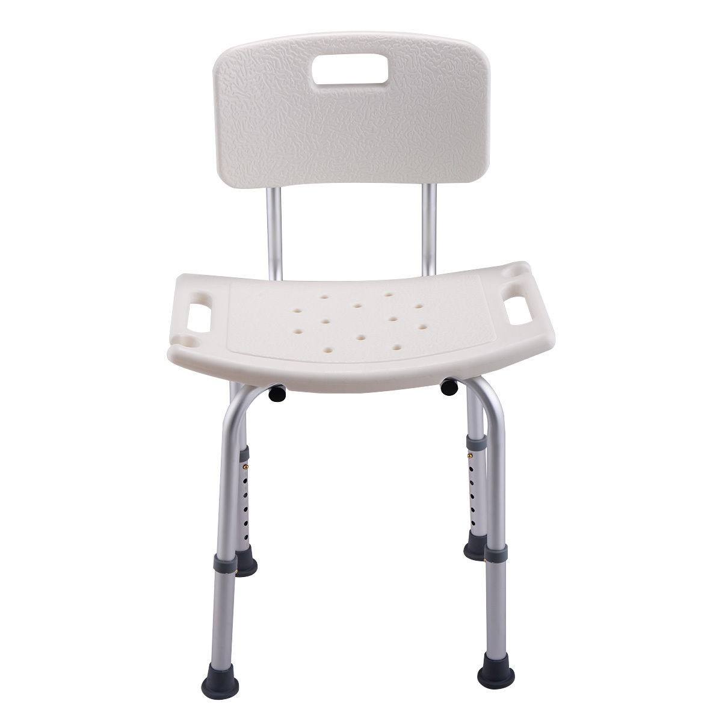 | $28-$50
Tools for Dressing

Item Name | Function |  | Price Range*
Sock Aid | Assists with putting socks on without bending over | 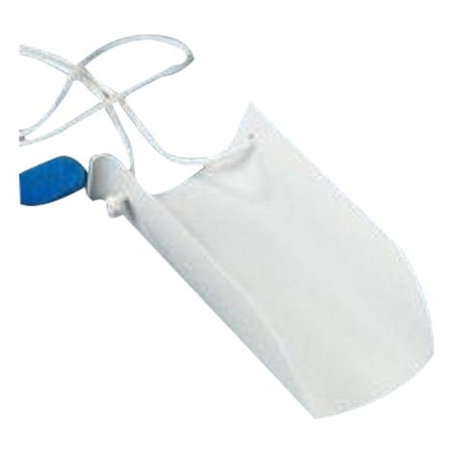 | $8-$15
Reacher | Assists with taking socks off, putting on underwear, and pants without having to bend over | 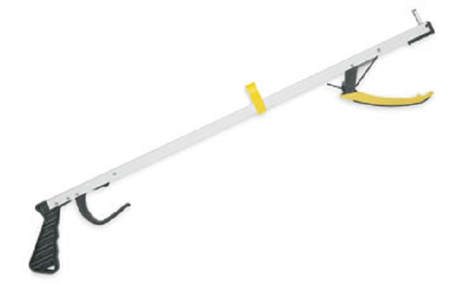 | $8-$17
Long Handled Sponge | Allows user to wash feet or lower legs without having to bend over | 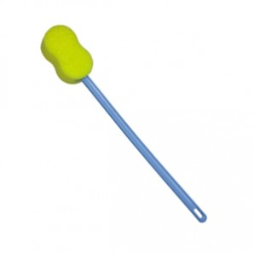 | $5-$10
“Hip Kit” | A pack of tools sold together. | 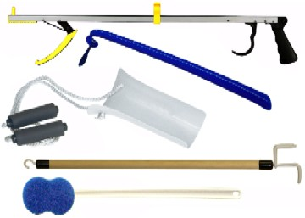 | $20-$40

Additional Tips:
- Set your home up for success before your surgery by clearing pathways for a walker to fit, removing throw rugs, and putting commonly used items in smaller containers at waist height
- Bring a comfortable outfit to wear home
  - Loose fitting pants, shirt, & slip on shoes. Flip flops are not recommended
DURABLE MEDICAL EQUIPMENT
Advanced Mobility..................................................(209) 722-0877
528 W. 27th Street, Merced, CA 95340
Power wheelchairs and scooters only

Apria Healthcare.....................................................(209) 384-7100
2260 Cooper Avenue, Unit E, Merced, CA 95348

Guardian Angel’s Medical Supply, Inc....................(209) 826-2223
222 I Street, Suite B, Los Banos, Ca 93635

Hanger Prosthetics & Orthotics..............................(209) 725-1295
436 E. Yosemite Avenue, Suite C, Merced, CA 95340

Life Care Solutions..................................................(209) 724-9078
3368 N. State Highway 59, Merced, CA 95348

Merced Medical Supply...........................................(209) 722-3832
1827 Canal Street, Merced, CA 95340

Pacific Medical, Inc.................................................(209) 722-2440
1180 W. Olive Avenue, Suite H, Merced, CA 95348
Prosthetics and Orthotics

Pacific Pulmonary Supply and Med Mart...............(209) 722-0680
450 Grogan Avenue Suite B, Merced, CA 95341

Premier Medical Supply..........................................(209) 537-2882
2800 Mitchell Road, Suite F, Ceres, CA 95307

Respicare..................................................................(209) 384-8167
3337 G Street, Suite A, Merced, CA 95340

Valley Healthcare Supply........................................(209) 725-1200
359 W. Main Street, Merced, CA 95340

Yosemite Medical Supply........................................(559) 683-5741
40148 Highway 41, Oakhurst, CA 93644

For more community resources information please visit Dignityhealth.org/Merced/CRG

