To Affiliate With Dignity Health:

Type in Dignity health and it should pop up.

Then I can assign the course to you or you can do it yourself by clicking on:
- View courses
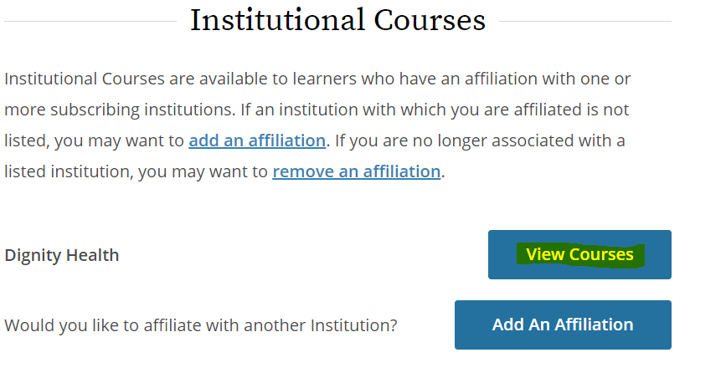

To Add DHRI Required Courses in CITI:

Then scroll down to the bottom of the page and select
- add a course
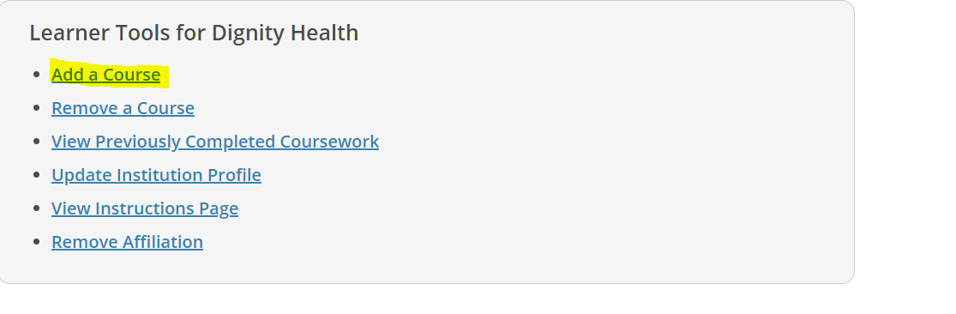

You will see the following Question 1; select the Yellow highlighted Group 1 course unless you are one of the following:

- an IRB member select the red highlighted Group 2 course or

- ONLY ON STUDIES THAT DO NOT INVOLVE AN INVESTIGATIONAL DRUG you have the option to select the green highlighted Group 3 course or Group 1 yellow highlighted course- note that you will need to go back and take the yellow selected course if you ever become involved in a study with investigational drugs so it is recommended to take the Group 1 training and cover all requirements from the beginning.

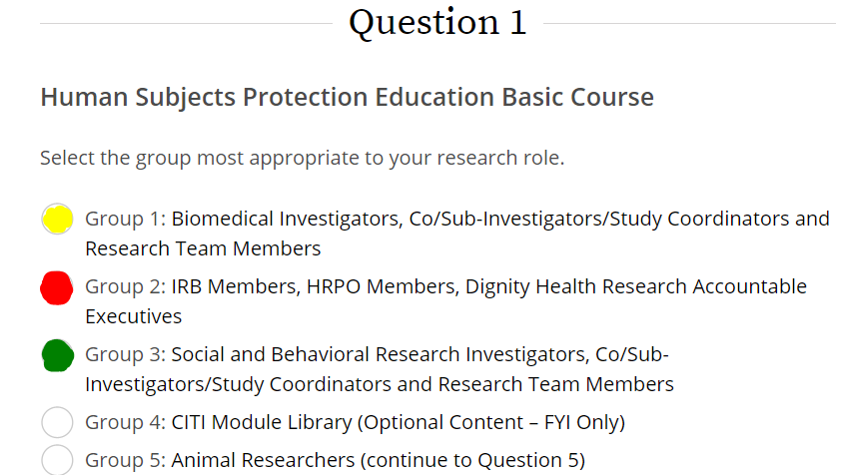

Next, only if applicable (which means if you are involved in federally funded research/using an FDA regulated product) select the appropriate course for question 2 :
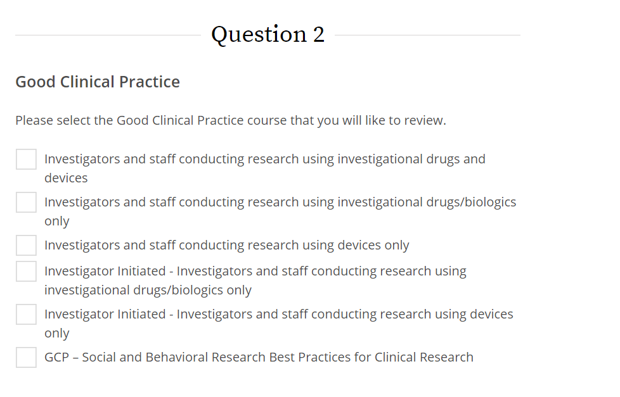

YOU DO NOT NEED TO SELECT ANYTHING ELSE UNLESS YOU WANT TO AS AN OPTIONAL COURSE- scroll to the bottom of the page and hit submit. Then you will be able to begin your training.

