CITI Enrollment Guide

- Create an Account ( If you have an account with another institution skip to step 2 on the next page)

Go to CITI: https://about.citiprogram.org/en/homepage/
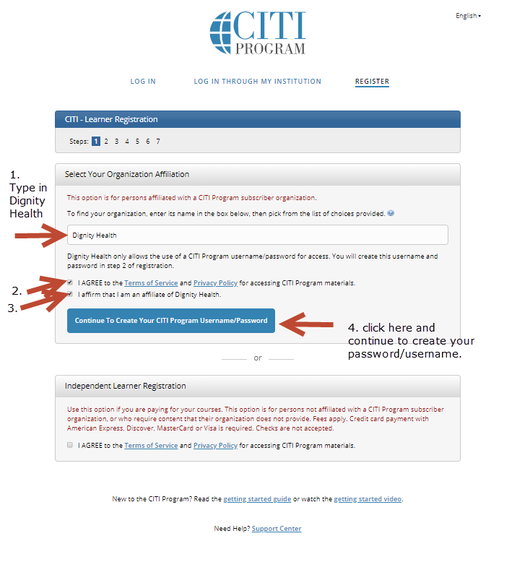

CITI Enrollment Guide

- Affiliate with Dignity Health (if you already have a CITI account with another institution):

Type in Dignity health and it should pop up.

Then the Training & Education Analyst (916) 851-2685 can assign the course to you or you can do it yourself by clicking on:

- View courses (as highlighted below)

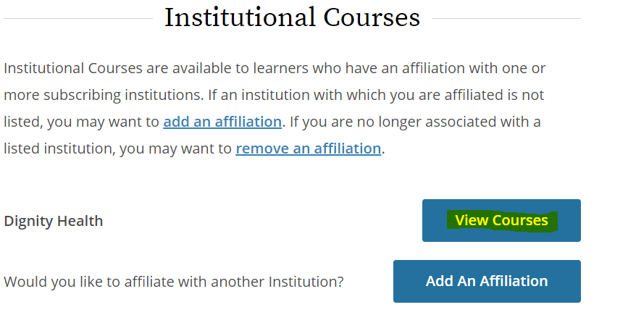

CITI Enrollment Guide

- Add DHRI Required Courses in CITI ( HSP & GCP if applicable):

Then scroll down to the bottom of the page and select
    - add a course (highlighted below)

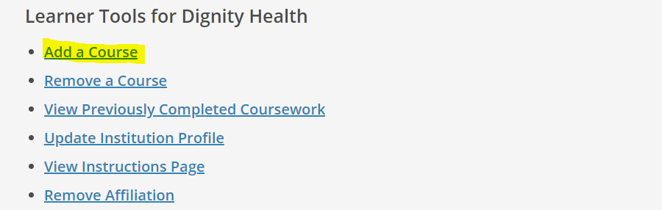

- HSP Training

You will see the following Question 1; select the Yellow highlighted Group 1 course unless you are one of the following:

- an IRB member select the red highlighted Group 2 course or

- ONLY ON STUDIES THAT DO NOT INVOLVE AN INVESTIGATIONAL DRUG you have the option to select the green highlighted Group 3 course or Group 1 yellow highlighted course- ***NOTE that you will need to go back and take the yellow selected course if you ever become involved in a study with investigational drugs so it is recommended to take the Group 1 training and cover all requirements from the beginning.***
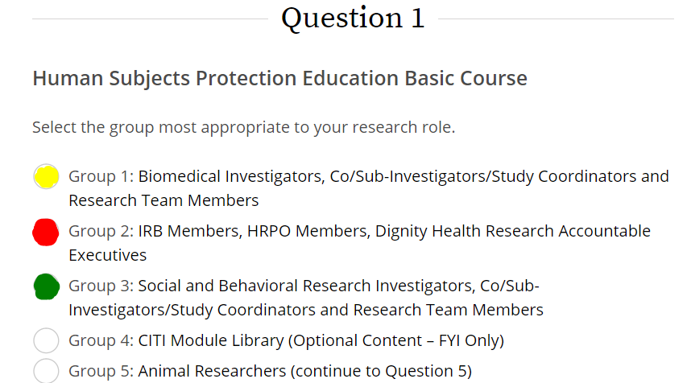

CITI Enrollment Guide
B. GCP Training

Next, only if applicable (which means if you are involved in federally funded research/using an FDA regulated product) select the appropriate course for question 2 (highlighted courses are recommended if they apply to your research):
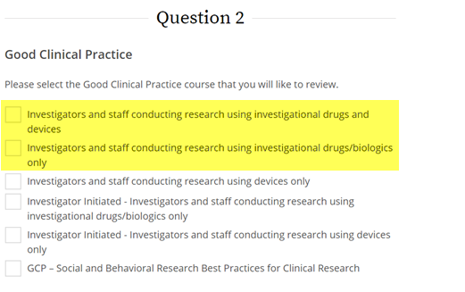

YOU DO NOT NEED TO SELECT ANYTHING ELSE UNLESS YOU WANT TO AS AN OPTIONAL COURSE- scroll to the bottom of the page and hit submit. Then you will be able to begin your training.

Suggested Optional Courses:

  - Question 5- Shipping and Transport of Regulated Biological Materials (if directed by supervisor)
  - Question 14- TransCelerate Requirements Training (for anyone needing to meet TransCelerate Requirements for a Sponsor)

